Advance Programming Diagrams

Class Diagram

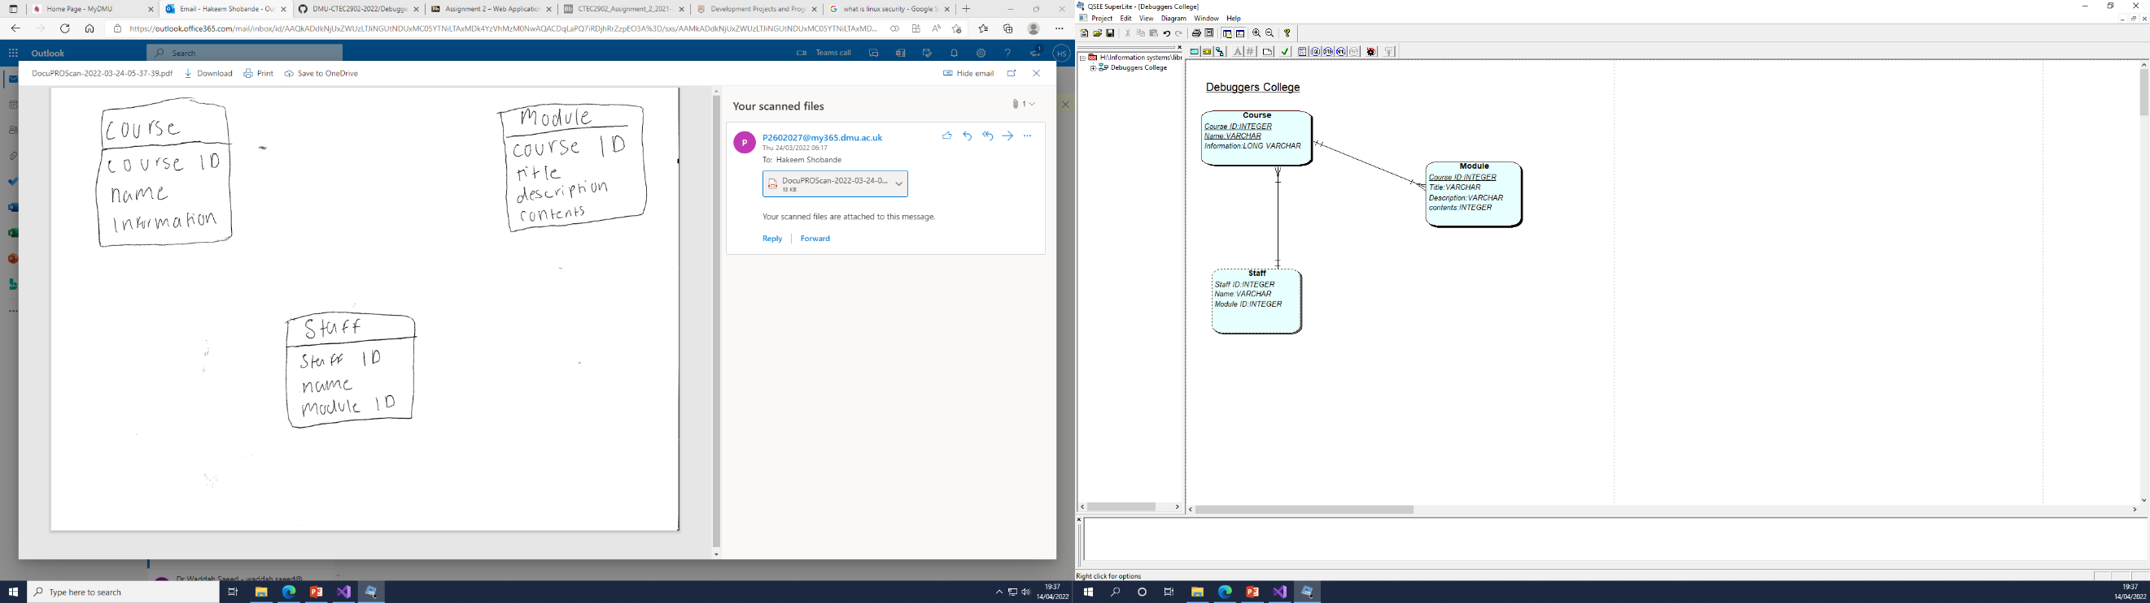

Use case Diagram

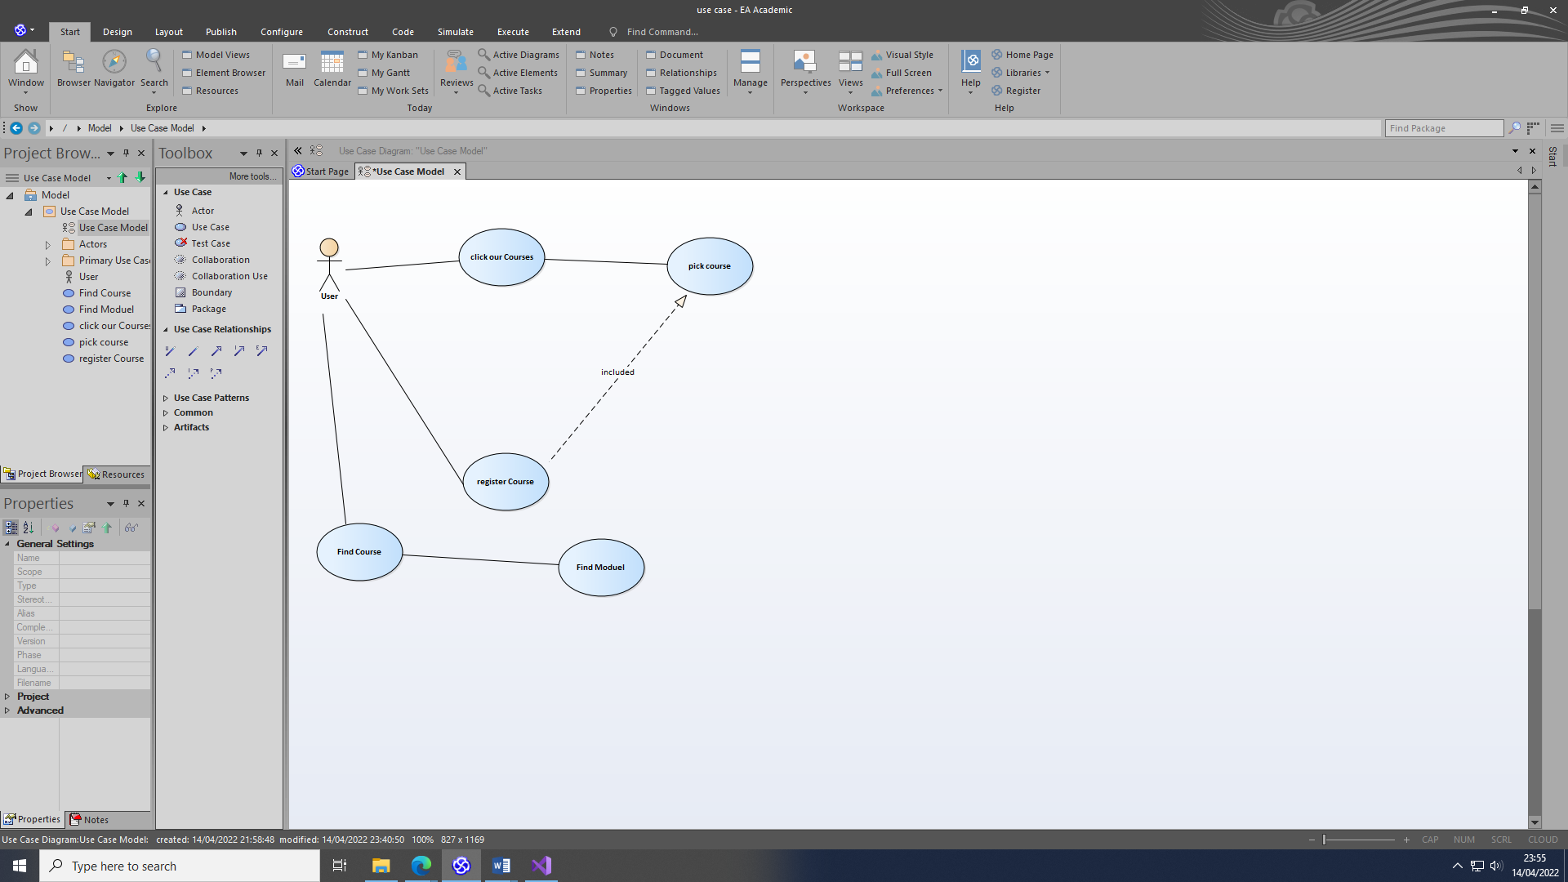

Use case Description

|  |  |
| --- | --- |
| Use Case Name | Find Course |
| Use Case Description | The user will be on the main menu to get to the course details |
| Use Case Author | Hakeem |
| Actor | User |
| Locations | The front end of the system |
| Primary Pathway | -User goes onto the system  -All courses are shown  -user clicks on the course  -This will take them to the course page |
| Alternate Pathways | N/A |
| Exception Pathways | N/A |

|  |  |
| --- | --- |
| Use Case Name | Register Course |
| Use Case Description | User will go from the main menu to the find course page then register for course. |
| Use Case Author | Hakeem |
| Actor | User |
| Locations | Front end of the system |
| Primary Pathway | -User goes onto the system  -All courses are shown  -user clicks on the course  -This will take them to the course page |
| Alternate Pathways | N/A |
| Exception Pathways | N/A |

Interface Design

Home Page

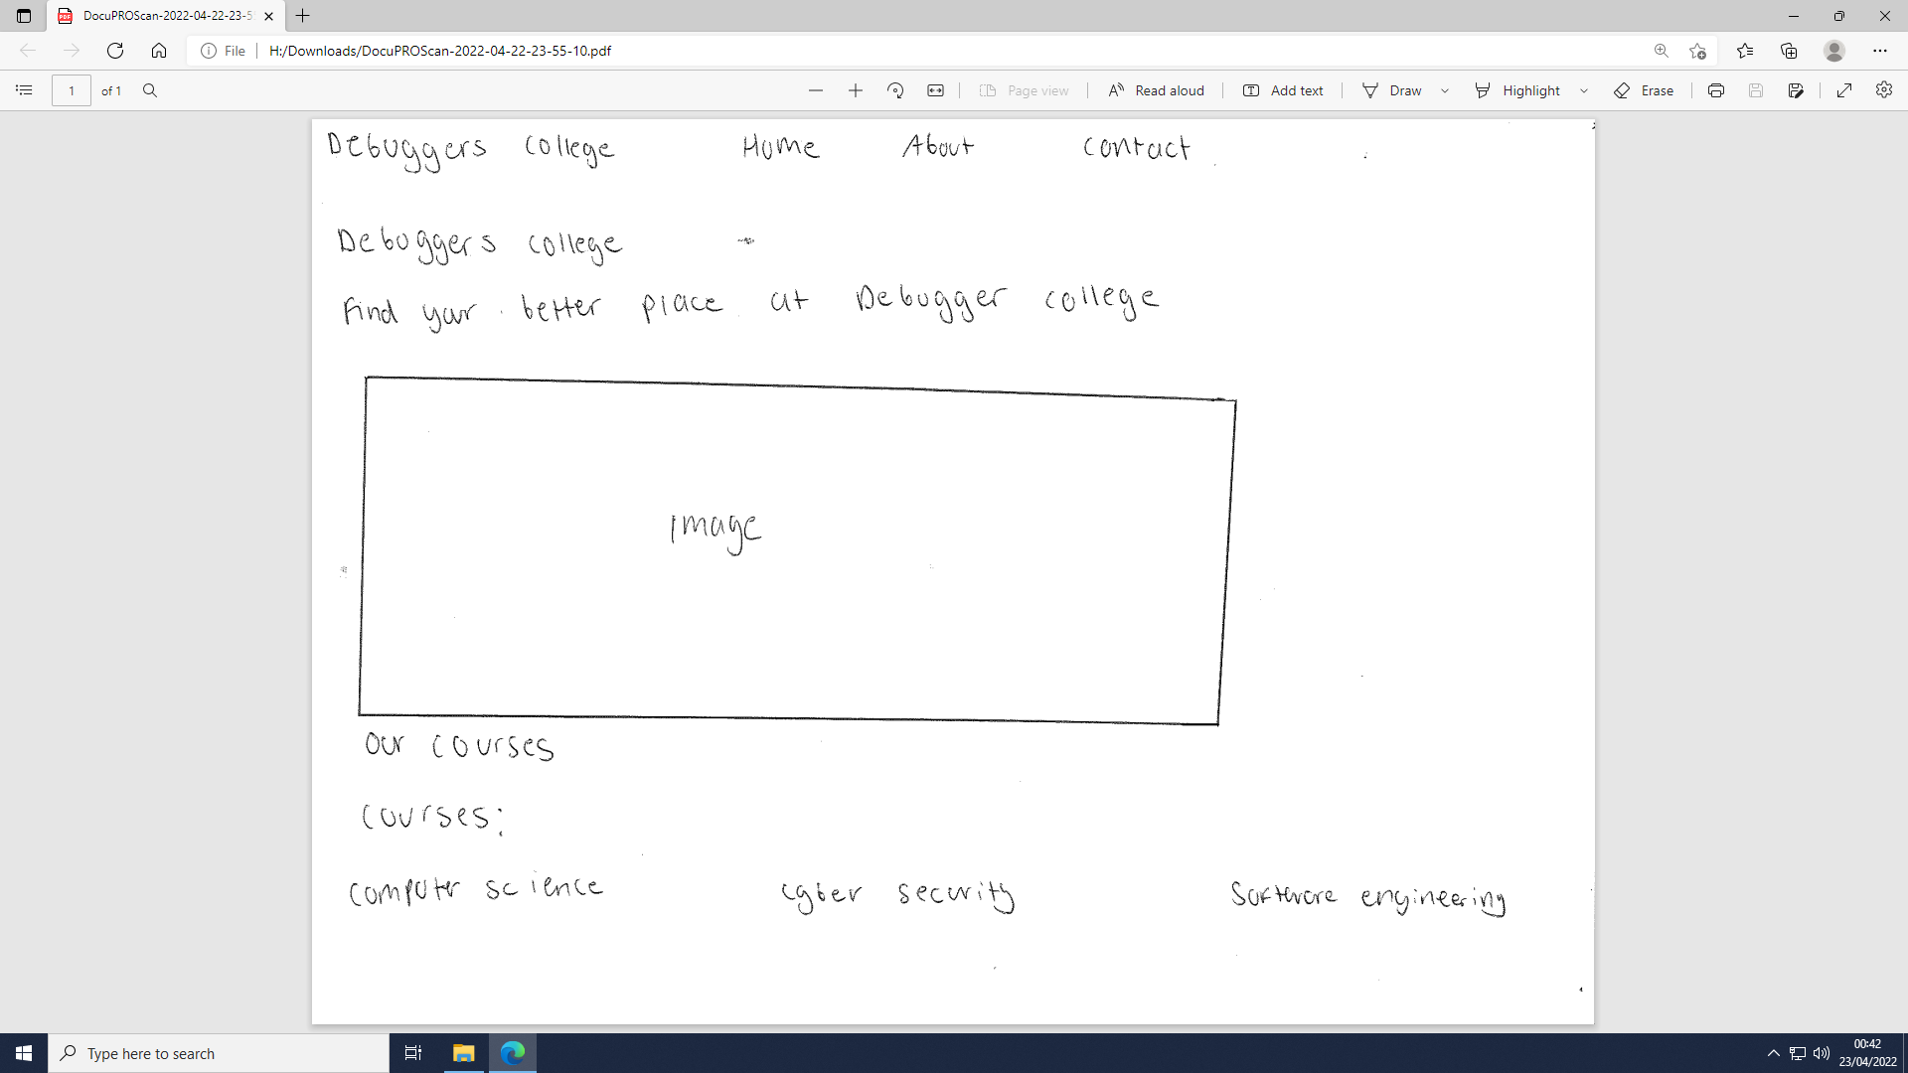

Course Page

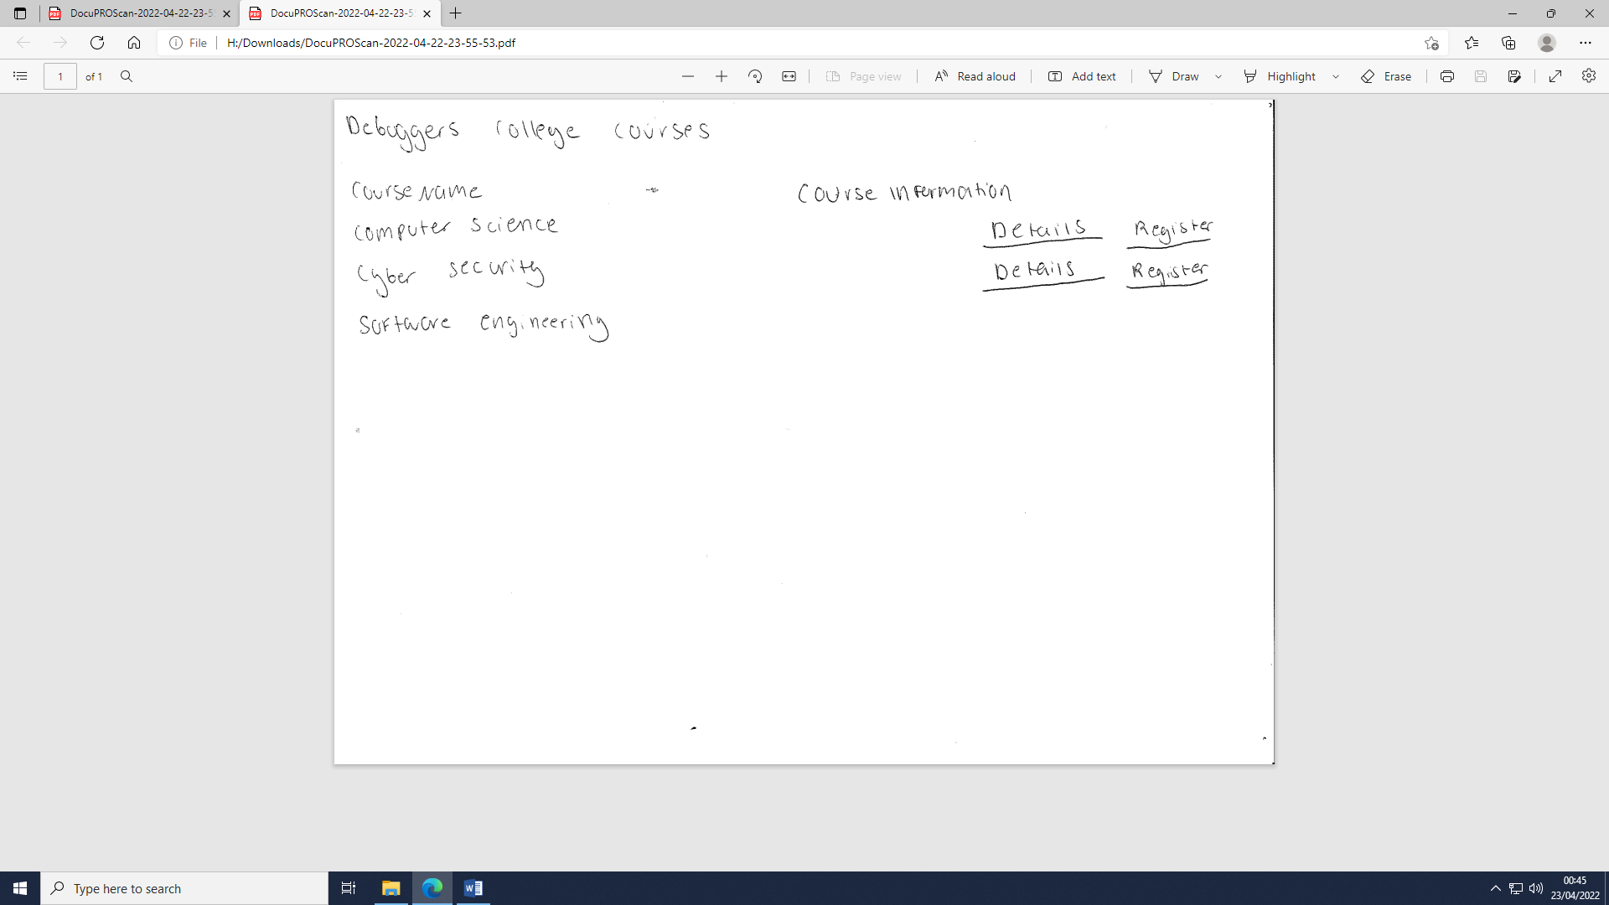

ERD

